

Practices for Secure Software Report

Project 2

Southern New Hampshire University

Professor Albanie Bolton

02/16/26

Thoura Chris Ouk

Table of Contents
Document Revision History 3
Client 3
Instructions 3
Developer 4
1. Algorithm Cipher 4
2. Certificate Generation 4
3. Deploy Cipher 4
4. Secure Communications 4
5. Secondary Testing 4
6. Functional Testing 4
7. Summary 4
8. Industry Standard Best Practices 4

Document Revision History

Version | Date | Author | Comments
1.0 | 02/16/26 | Thoura Chris Ouk

Client



Instructions

Submit this completed practices for secure software report. Replace the bracketed text with the relevant information. You must document your process for writing secure communications and refactoring code that complies with software security testing protocols.

- Respond to the steps outlined below and include your findings.
- Respond using your own words. You may also choose to include images or supporting materials. If you include them, make certain to insert them in all the relevant locations in the document.
- Refer to the Project Two Guidelines and Rubric for more detailed instructions about each section of the template.

Developer
Thoura Chris Ouk

Algorithm Cipher

From what I have learned so far, I believe that the best algorithm cipher to use is SHA-256 from the SHA-2 family. This uses a one-way cryptographic hash function that takes input data of pretty much any size and produces fixed 256-bit digest. That is the same as 32 bytes. Any single or small change will result in a completely different output. This is known as the avalanche effect. This algorithm is considered secured against current computational capabilities. This also uses random numbers which will have tampering detections without needing encryption.

Certificate Generation
Insert a screenshot below of the CER file.

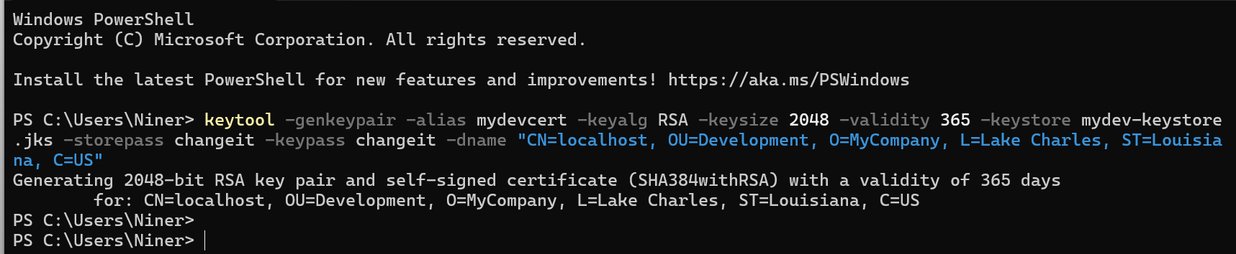

Deploy Cipher
Insert a screenshot below of the checksum verification.

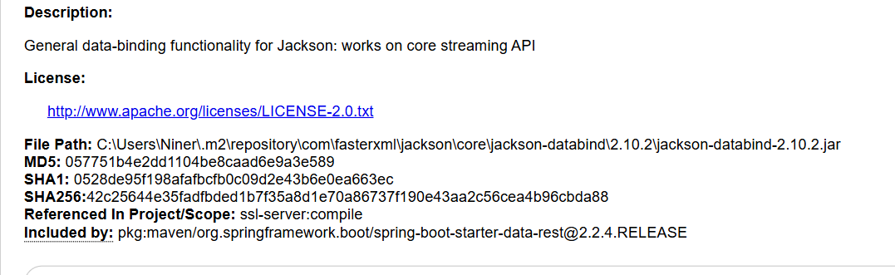

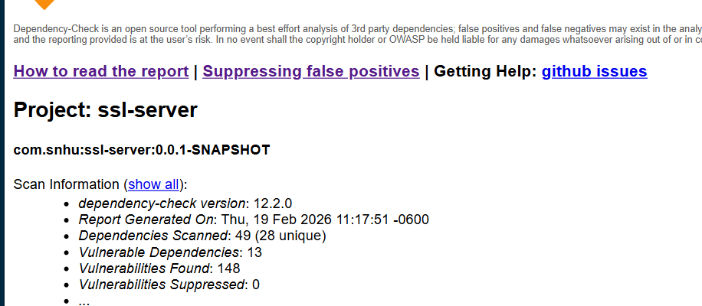

I’m not sure how to do this part and I had help with academic support too. I still could not generate the proper site.

Secure Communications
Insert a screenshot below of the web browser that shows a secure webpage.

Secondary Testing
Insert screenshots below of the refactored code executed without errors and the dependency-check report.

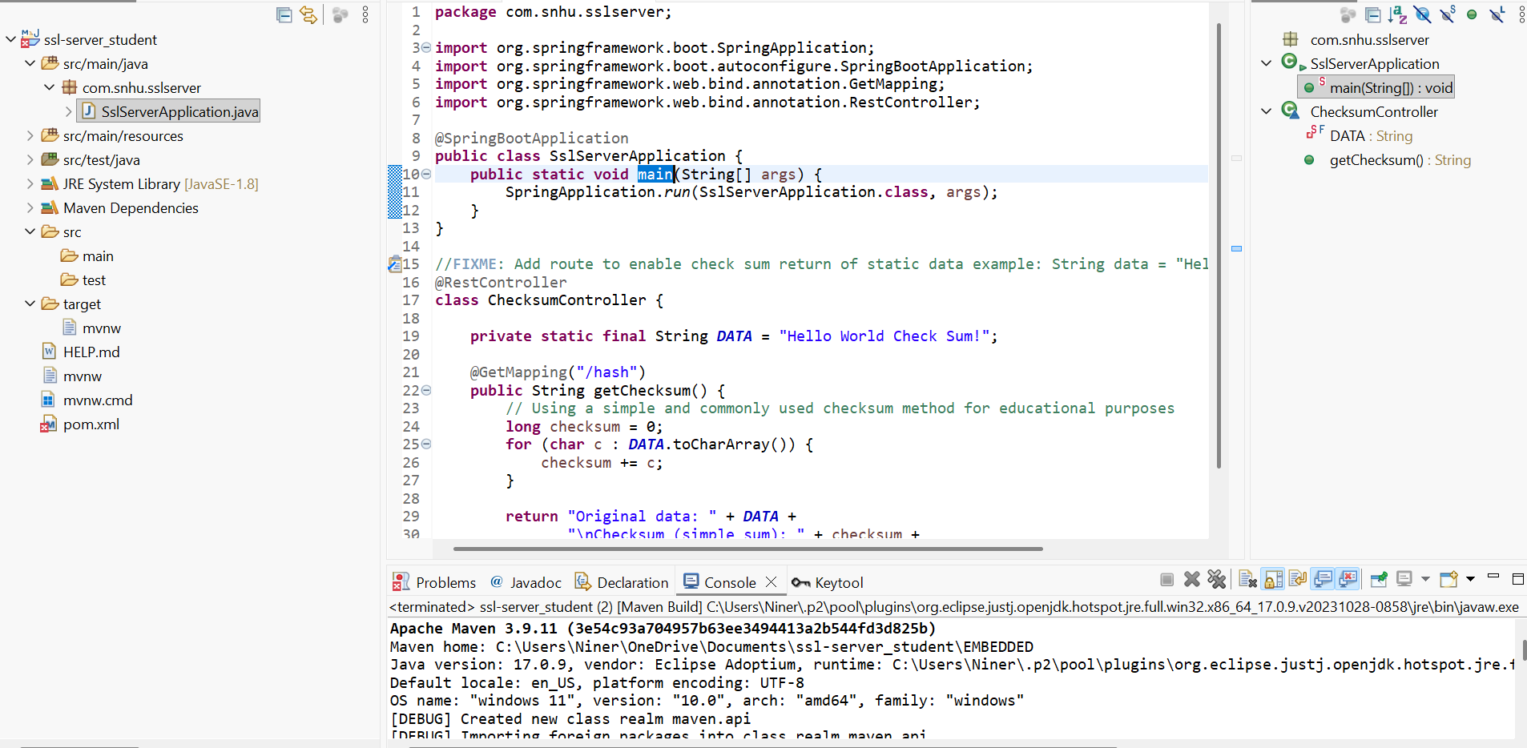

return "Original data: " + DATA +
"\nChecksum (simple sum): " + checksum +
"\nIn hex: 0x" + Long.toHexString(checksum).toUpperCase();
}
}

Functional Testing
Insert a screenshot below of the refactored code executed without errors.

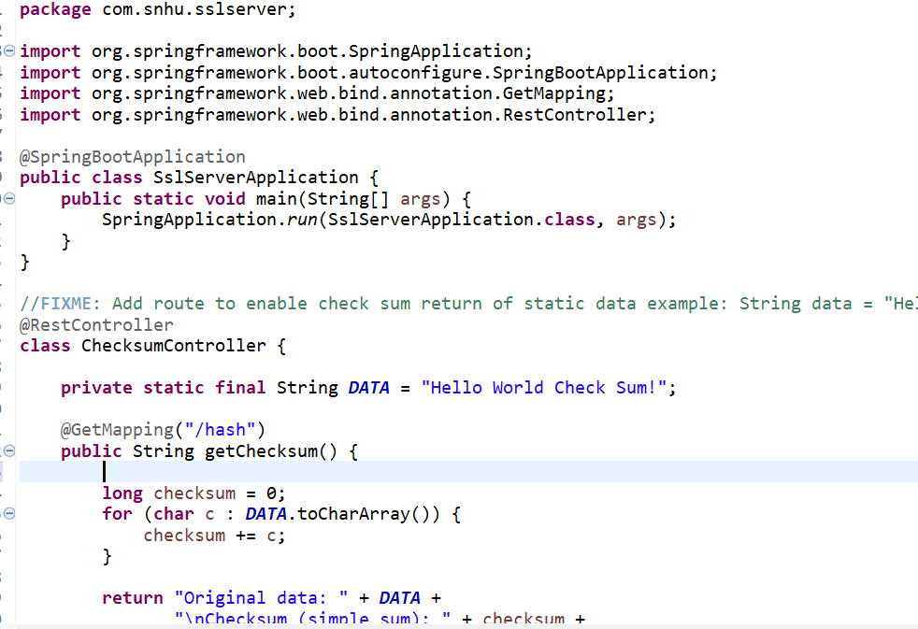
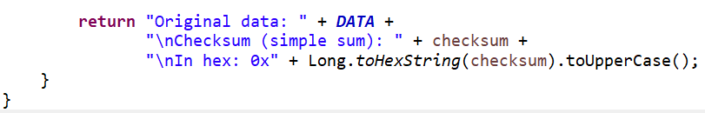

Summary

The original code looks like it may have used SHA-256 to checksum verification for data integrity and HTTPS for more secure transport. So, I believe that this will address more key areas in the vulnerability assessment or security verification process. I’m just not exactly too sure how to make a code that has pretty much is data integrity free. My process also involved assessing risks, testing iteratively and re-verifying with static tools. The whole point is giving Artemis Financial the best online security possible.

Industry Standard Best Practices

I think I did the best I could using the best industry standard practices. Using the OWASP secure coding practices and NIST guidelines. Using strong, current algorithms SHA-256. The code I made has proof of generating a development SSL certificate. Implementing these practices will help Artemis Financial reduce breach risk, protects client financial data, builds trust, having good compliance and have long term maintainability.

